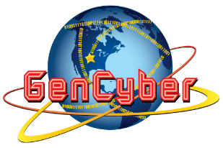

July 11, 2016

Honorable John T. Error

Somecity, ST 09091

Dear Mr. Error:

We deposited the funds amounting to $75,000,003.99 to your account (Account # 010-7865-8775) at Banana Republic Bank and Trust, Chicago branch on July 4, 2016. Please acknowledge receipt by texting to my mobile phone (256-876-9009) the code words “nice try.”

We hope that you will promptly deliver your promise to sign the approval of our trade agreement to ship 2500 nuclear warheads to wiki-wiki island before the end of this month.

Respectfully,

Jane Angry Bird

CEO, NukeThemAll Inc.